Executive summary
Key finding: Males in your cohort show higher absolute power, jump height, and peak velocity; females show two distinct strategies—tendon-dominant (elastic) and muscle/force-dominant (inefficient)—with different injury risks. Practical implication: monitoring and interventions must be sex-informed and phenotype-specific rather than using a single, unisex threshold.

Here is a detailed explanation of this topic, drawing on Player 741's specific metrics and biomechanical implications:

The profile described for Player 741—a force-dominant, mechanically inefficient jumper—is a specific athletic phenotype characterized by a mismatch between muscular output (force/power) and elastic efficiency (jump height). This profile is also known as a "High-Force, Knee-Risk Profile".
Here is a detailed explanation of this topic, drawing on Player 741's specific metrics and biomechanical implications:
1. Definition and Performance Metrics
Player 741's profile is categorized as force-dominant and low-efficiency. This designation is supported by the following metrics:
• High Peak Power: Player 741 generates high peak power (approximately 3627 W), which is noted as being above the team average. This indicates significant concentric strength in her lower body.
• Modest Jump Height: Despite the high power, she only achieves a modest jump height of approximately 0.27 meters.
• Low Efficiency: The comparison of high power output to low vertical lift shows she is mechanically inefficient.
2. Underlying Biomechanical Strategy
The key to understanding the mechanical inefficiency lies in her jump strategy, which relies heavily on muscular strength rather than elastic energy storage and return:
• Muscle–Tendon Unit Strategy: Player 741 exhibits a heavy reliance on quadriceps/glute concentric strength. This suggests a “soft” muscle–tendon unit.
• Limited Stretch–Shortening Cycle (SSC) Use: The strategy involves limited use of the stretch–shortening cycle (SSC), which is the mechanism where tendons and muscles efficiently store and release energy during rapid movements (like jumping or running).
• Modified Reactive Strength Index (mRSI): This limited elastic capacity is quantified by a very low mRSI of 0.36. This low mRSI matches the “high-force, low-efficiency” profile described in the sources for low mRSI athletes.
• Inconsistent Control: The profile also features high variability (CV ≈23.5), indicating inconsistent neuromuscular control. Player 741’s mRSI slopes are often weak or noisy, which is consistent with her high-variability, muscle-dominant nature.
3. Elevated Injury Risks (Knee-Dominant Strategy)
Because Player 741 generates force through a knee-dominant strategy and lacks elastic stiffness, she is predisposed to joint-related injuries. Her overall profile is considered a High-Force, Knee-Risk Profile.
• Patellofemoral Pain Risk: Her strategy involves deep knee flexion and high quadriceps loading, which increases stress on the patellofemoral joint. The deep knee-flexion strategy, implied by the low mRSI and high power, increases compressive forces on the patellofemoral joint and can exacerbate lateral patellar tracking dysfunction.
• Non-Contact ACL Injury Risk: The low stiffness and high variability predispose her to dynamic knee valgus (a knee cave-in) when under fatigue. Dynamic knee valgus is a primary mechanism for non-contact Anterior Cruciate Ligament (ACL) injury, particularly during landing and deceleration maneuvers.
• Workload Context: Her primary risk is attributed to poor landing mechanics and this knee-dominant strategy, rather than spikes in overuse volume, as her overall workload metrics are relatively stable.
4. Practical Interventions
Given the mechanical deficiencies and elevated knee risk, the analysis suggests targeted intervention is necessary for Player 741:
• Intervention Priority: Player 741 is a priority for neuromuscular retraining.
• Focus Areas: Training should focus on improving stiffness, developing eccentric control, and establishing valgus-resistant movement patterns.
• Training Risk: If her Peak Propulsive Power and Peak Velocity improve without concurrent improvement in landing mechanics and neuromuscular control (as indicated by stable or noisy mRSI trends), her ACL and patellofemoral risk may be sustained or even increased.
--------------------------------------------------------------------------------
The force-dominant, mechanically inefficient profile can be likened to a heavy truck driver trying to win a speed race in a tight canyon. The truck generates huge engine power (high peak power), but its soft suspension and heavy frame mean that when the driver tries to spring off a curve, the energy is mostly absorbed by the suspension and frame flexing (deep knee flexion/soft muscle-tendon unit), rather than translating into fast, efficient forward motion (low jump height). The high power is present, but it's used inefficiently and places immense, uncontrolled stress on the system (knee joint risk).

Here is a detailed explanation of Player 555’s profile, its performance metrics, and the associated injury risks:
1. Definition and Performance Metrics
Player 555 exhibits a profile defined by efficient biomechanics and stability, demonstrating a tendon-dominant, elastic strategy. This means she relies heavily on the stiffness and recoil of her tendons, such as the Achilles and plantar fascia, rather than brute muscular effort.
Her performance is characterized by the following key metrics:
• Elite Modified Reactive Strength Index (mRSI): Player 555 has an elite mRSI of 0.52. This metric (jump height divided by time to takeoff) directly measures the efficiency of the stretch-shortening cycle (SSC). Her high mRSI indicates efficient use of the stretch-shortening cycle.
• Very Low Variability: She exhibits very low variability (CV 5.2). This low variability points to a highly consistent neuromuscular output and stable performance.
• Modest Jump Height: Her jump height is slightly higher than Player 741's, at approximately 0.31 meters.
• Low Peak Power: Despite her mechanical efficiency, her peak power is low (approximately 3100 W). This value is noted as being below the 4000 W threshold, identifying her as "underpowered".
2. Underlying Biomechanical Strategy (Tendon-Dominant)
The "tendon-dominant" nature of Player 555's strategy stems from her ability to leverage the Stretch–Shortening Cycle (SSC) effectively.
• SSC Efficiency: The SSC involves three phases: eccentric loading (tendons stretching), amortization (transition), and concentric recoil (propulsion). Player 555’s elite mRSI (0.52) shows she excels at this process, maximizing the elastic return from her tissues.
• Stiff Achilles and Plantar Fascia: This efficiency relies on a stiff Achilles and plantar fascia. Tendons act like stiff springs, allowing energy to be stored and rapidly released.
• Strategy Contrast: This strategy contrasts sharply with Player 741's "soft" muscle-tendon unit, which relies on deeper joint flexion and concentric muscle strength (force-dominant).
3. Primary Injury Risks
While Player 555’s mechanical profile is efficient, it shifts her injury risk away from the acute, joint-related problems (like ACL tears seen in 741) toward chronic tendon and muscular issues related to high tensile loads.
• Tendon Overload (Achilles Tendinopathy): Her reliance on a stiff Achilles and plantar fascia increases tensile load and the risk of micro-trauma. This predisposes her to Achilles tendinopathy. The literature supports the association between high elastic stiffness and fast SSC usage and tendon overload when training volume or recovery is poorly managed.
• Hamstring Strain: Player 555 has a higher Peak Velocity (≈7.2 m/s) than some peers, which raises her susceptibility to hamstring strain if her eccentric strength is inadequate. Hamstring strain risk increases due to the maximum eccentric tension required during the deceleration of the leg swing in the terminal swing phase of sprinting.
4. Practical Implications and Intervention
Player 555 requires targeted intervention to address her low power capacity while carefully protecting her existing elastic qualities.
• Training Focus: Her intervention focuses on strength and load management. The overall goal is to increase her low peak power (currently 3100 W).
• Risk Management: It is critical to monitor weekly Distance Total and morning Achilles stiffness. Spikes of +20% Acute-to-Chronic Workload Ratio (ACWR) must be avoided, as high elastic stiffness athletes are susceptible to tendon overload when volume or recovery is poorly managed.
• Training Considerations: Her already high mRSI should be preserved and not pushed further with excessive plyometric volume, which could exacerbate tendon risk. Regression analysis showed Player 555's mRSI remained stable and high, matching her tendon-dominant profile.
--------------------------------------------------------------------------------
Analogy: If Player 741 is a heavy truck relying on engine power and deep suspension travel, Player 555 is like a precision sports car with very stiff, tightly wound springs (tendons). Her system is light, responsive, and incredibly efficient at recycling energy to achieve lift (high mRSI), but her "engine" (peak power) is small. If you overload the car or force it to run too long without maintenance, the stiff springs themselves will wear out or snap (tendon overload) instead of the soft suspension bottoming out.

Here is a detailed explanation of why Players 755 and 995 are predisposed to patellar tendinopathy, low back, and hip overload
1. The Typical Male Division I Profile
Male players generally exhibit higher absolute performance metrics compared to their female counterparts due to factors like body mass and muscle architecture:
• They show higher absolute power and speed.
• They display a greater tolerance for load.
• They typically achieve higher jump heights (40–75 cm).
• Their performance trend over time often shows "textbook" male adaptation, meaning clearer positive slopes in Jump Height, Peak Propulsive Power (PPP), and Peak Velocity, achieving more power and speed per unit load.
• Medically, they appear at lower non-contact ACL risk than Player 741 due to generally higher stiffness and better velocity profiles.
2. The Overuse Risk Factors
Despite their superior performance capacity, the men face increased risk for overuse injuries because their training demands often outpace their foundational strength and recovery management.
The risk stems from two main combined factors:
A. High Cumulative Workloads
Male collegiate athletes, particularly in basketball, sustain high cumulative workloads.
• Player 755 specifically illustrates this risk: he exhibits a Force-Work Capacity profile and averages 4,060 meters per session, which is 33% higher external load than Player 995.
• This high external load leads to a chronic residual fatigue state.
• The literature on male athletes supports that their risk increases when Acute-to-Chronic Workload Ratio (ACWR) thresholds are exceeded.
B. Lagging Strength Capacity
Both male players were flagged as needing strength work in the Player Performance Report.
• The risk of overuse injuries increases when strength lags behind workload.
• While Player 995 is an Explosive-Reactive profile with high mRSI, his overall power capacity may still need elevation.
• Player 755’s stable Jump Height combined with a significantly low mRSI (0.43) and slow Peak Velocity (2.65 m/s) indicates a compensatory strategy where he uses muscular effort (like increased knee bend) to maintain height despite severe loss of reactive capacity due to chronic fatigue. This heavy, inefficient movement pattern places greater stress on specific structures.
3. Specific Overuse Injuries
The combination of high load and insufficient strength/recovery directly targets structures prone to continuous impact and tension:
• Patellar Tendinopathy (Jumper's Knee): This is a key overuse risk. When athletes rely heavily on high-volume jumping and running, the tendon connecting the kneecap to the tibia is subjected to repetitive tensile stress. The sources note that this pattern matches findings for male collegiate basketball and football athletes.
• Low Back and Hip Overload: The high cumulative workloads and speed demands expose the hips and lower back to repetitive impact and muscular strain, leading to overload. This is particularly true if the athletes lack the core and posterior chain strength needed to stabilize the torso during powerful movements and long training sessions, especially given the identified need for strength work.
4. Intervention Strategy
The analysis recommends a specific intervention strategy for the male players to mitigate these overuse risks:
• Progressive Strength and Controlled Workload Ramp-Up: This is the suggested intervention for both Players 755 and 995.
• Targeted Reduction: For Player 755, reducing his Distance Total by 20% for two weeks is recommended to address the chronic fatigue and allow neuromuscular recovery. The goal is to facilitate an mRSI rebound and restoration of movement efficiency.
The male players' profiles are like high-performance commuter vehicles: they can handle high mileage and speed better than a specialized race car (like Player 555) or a structurally compromised vehicle (like Player 741). However, if they are driven hard every single day (high cumulative workload) without regular, comprehensive maintenance (strength work lagging behind volume), their reliable components—like the tendons and stabilizing joints in the knee, hip, and back—will begin to break down slowly from cumulative wear and tear (overuse injuries)

Section 1: Combined Group Statistical Med Analysis
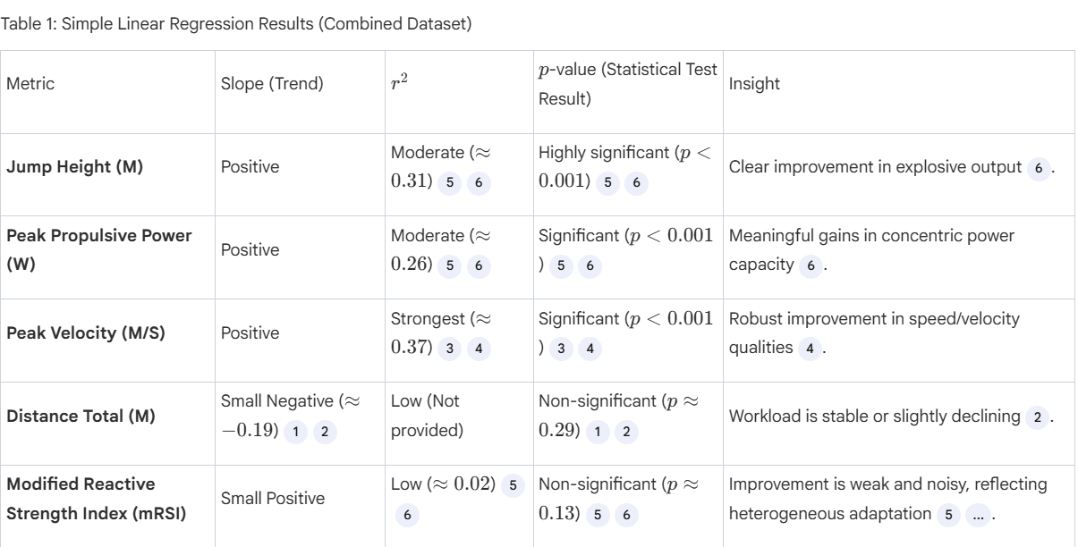
Key Findings from Group Analysis
1. Training Efficiency: The group is maintaining or slightly reducing total workload (non-significant decline in Distance Total) while significantly improving Jump Height, power (PPP), and velocity. This indicates a positive signal for training efficiency (more output per unit load).
2. Heterogeneous Adaptation (mRSI): The flat or noisy mRSI trends suggest that underlying stiffness and landing strategy are not uniformly improving across the group. This matches the split between the low-stiffness, high-variability profile (Player 741) and the high-stiffness, low-variability profile (Player 555).
3. Risk Implications: Improving power and velocity without large workload growth supports better force–velocity capacity and may lower injury risk for athletes with good mechanics (like Player 555). However, for the force-dominant, low-mRSI athlete (Player 741), this sustains or can increase knee risk if landing control is not improved.
--------------------------------------------------------------------------------

Section 2: Individual Player Profiles and Performance Gaps
The four athletes show distinct performance and injury-risk profiles, with the women illustrating contrasting neuromuscular strategies and the men highlighting typical Division I conditioning needs
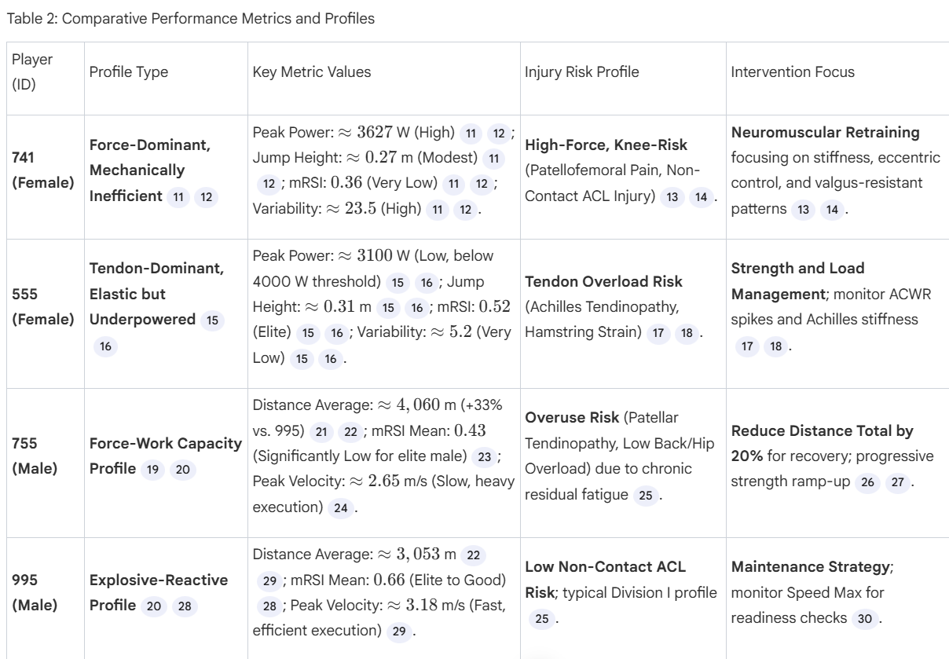

Female athletes: phenotypes, mechanisms, and medical implications
Phenotype A — Tendon-dominant, elastic (example Player 555)
- Profile: High mRSI, low variability, relatively lower peak power but higher jump height per unit power.
- Mechanism: High tendon stiffness and efficient stretch-shortening cycle; propulsion relies on elastic recoil.
- Primary medical risks: Achilles tendinopathy, proximal hamstring strain under high sprint/velocity loads.
- Clinical markers to monitor: mRSI stability, morning Achilles stiffness, sudden +20% weekly Distance_Total spikes, eccentric hamstring strength.
- Operational rules: preserve plyometric/elastic work; limit weekly distance spikes to ≤20%; add progressive eccentric strength for posterior chain; flag for clinical review if mRSI drops >10% from baseline or if tendon pain emerges.

Phenotype B — Muscle/force-dominant, inefficient (example Player 741)
- Profile: High peak power, low mRSI, high variability (high CV), low jump height relative to power.
- Mechanism: Reliance on concentric muscle work (quads/glutes) with low tendon stiffness and poor amortization; landing mechanics often knee-dominant.
- Primary medical risks: Patellofemoral pain, dynamic valgus leading to elevated non-contact ACL risk, meniscal overload.
- Clinical markers to monitor: mRSI mean and CV, frontal plane knee mechanics, asymmetry >10%, persistent anterior knee pain.
- Operational rules: suspend high-impact plyometrics until mRSI CV <10% and landing mechanics improve; implement neuromuscular retraining emphasizing eccentric control, hip abductor strength, and valgus-resistant landing patterns; refer for physiotherapy if pain or asymmetry persists.
Male athletes: common profiles, mechanisms, and medical implications
Profile A — Explosive-reactive, balanced (example Player 995)
- Profile: High mRSI, high peak velocity, moderate Distance_Total.
- Mechanism: Good tendon stiffness and neuromuscular readiness; efficient force-velocity expression.
- Primary medical risks: Overuse if workload escalates rapidly; hamstring strain if eccentric capacity lags behind speed.
- Operational rules: maintain current load; use Speed_Max <90% of PB as a trigger for short recovery (3–5 days); monitor Peak Propulsive Power for consecutive drops >5%.
Profile B — Volume-driven, overloaded (example Player 755)
- Profile: High Distance_Total, low mean mRSI, high variability, slower peak velocity despite maintained jump height.
- Mechanism: Chronic residual fatigue; muscular compensation (greater knee flexion, longer ground contact) to preserve jump height.
- Primary medical risks: Patellar tendinopathy, low back and hip overload, reduced reactive capacity increasing injury susceptibility.
- Operational rules: apply a 15–25% reduction in Distance_Total for 7–14 days when mean mRSI < cohort threshold and variability is high; replace some volume with targeted intensity work (sprint-power, short plyometrics) and reassess mRSI weekly.
Practical protocols (metric → action)
- High Distance Total + low mRSI (Volume Trap)
  - Action: Reduce session distance by 15–25% for 7–14 days; replace low-value volume with targeted plyometrics or sprint-power sets; monitor mRSI weekly for rebound ( https://journals.plos.org/plosone/article?id=10.1371/journal.pone.0324702).
- Low mRSI with high Peak Power (female force-dominant, e.g., P741)
  - Action: Prioritize neuromuscular retraining, eccentric control, valgus-resistant landing drills, and limit high-impact plyometric volume until mRSI variability <10%. (https://journals.plos.org/plosone/article?id=10.1371/journal.pone.0324702)
- High mRSI but low Peak Power (female tendon-dominant, e.g., P555)
  - Action: Preserve elastic work (limit sudden +20% distance spikes), add progressive strength (hip/hamstring eccentric) to raise power while monitoring tendon symptoms. (https://www.mdpi.com/2075-4663/13/9/292)
- Stable high mRSI and Speed Max (male explosive, e.g., P995)
  - Action: Maintain load; use Speed Max <90% of PB as trigger for short recovery (3–5 days) or reduced intensity sessions. (https://journals.plos.org/plosone/article?id=10.1371/journal.pone.0324702)
Readiness flags → operational decisions
- Green (within thresholds): full participation; maintain current load and schedule high-intensity drills.
- Amber (5–15% drop in key metric or asymmetry >10%): modify drills to technical/skill work, reduce volume by 10–15%, add targeted neuromuscular warm-ups.
- Red (>15% drop, persistent low mRSI, or pain): remove from high-impact drills; prescribe recovery block (active recovery, physiotherapy), and require metric recovery to amber before reintroduction. ( https://bjsm.bmj.com/content/57/10/602)
Risks, limitations, and monitoring
- Risk: applying male absolute thresholds to female athletes masks tendon vs muscle strategies and raises ACL/tendon injury risk.
- Mitigation: use individual baselines and sex-stratified thresholds; track variability (CV) as an early warning sign; combine external load (Distance) with neuromuscular markers (mRSI, Peak Velocity) for decisions.

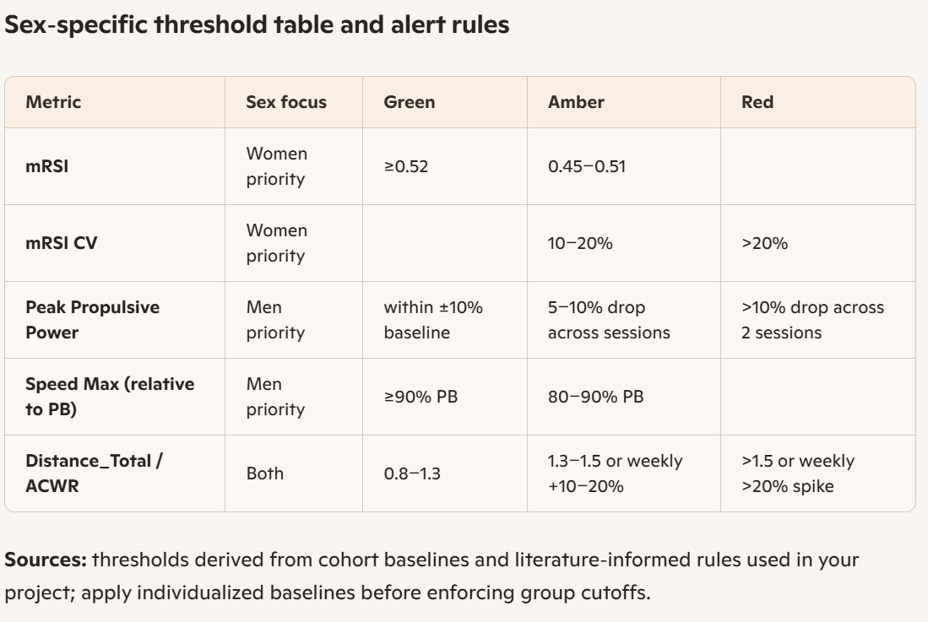 Readiness flags mapped to operational decisions
- Green: full participation; schedule high-intensity and game-specific drills.
- Amber: modify session content—reduce plyometric volume 10–15%, emphasize technical/neuromuscular drills, add targeted strength work. Monitor flagged metrics daily for women and 2–3×/week for men.
- Red: remove athlete from high-impact drills; implement active recovery and clinical assessment. For women with low mRSI and high CV, prioritize neuromuscular retraining and biomechanical assessment. For men with overloaded profile, apply immediate 15–25% volume reduction and replace distance with intensity work.
Clinical monitoring protocol to include in Methods
- Baseline period: 6–12 weeks to compute individual mean and CV for mRSI, Peak Power, Peak Velocity, Speed_Max, Distance_Total.
- Daily screens: mRSI and symptom check for women; morning tendon stiffness questionnaire for tendon-dominant athletes.
- Rolling metrics: 7-day ACWR for Distance_Total; 3-session moving average for Peak Propulsive Power.
- Trigger logic: require persistence of deviation (e.g., 2 consecutive sessions or 7-day trend) before applying Red interventions to avoid over-reacting to single outliers.
- Clinical escalation: persistent Red flag >7 days or any pain → physiotherapy evaluation and movement analysis.
Recommendations for your literature paper
- Frame sex as a moderator: present statistical interaction tests showing that the relationship between workload and neuromuscular markers differs by sex and by female phenotype.
- Report phenotype prevalence: quantify how many female athletes are tendon-dominant vs force-dominant and show their distinct injury outcomes or near-misses.
- Include operational thresholds: provide the sex-specific table above and justify each cutoff with cohort baseline statistics and cited literature on RSI, ACWR, and injury risk.
- Emphasize variability: include CV as a predictor variable; show that high CV in mRSI predicts knee injury risk in force-dominant females.
- Clinical translation section: give explicit coach/clinician decision trees mapping flags to actions, as above, and include sample 2-week intervention protocols for Red flags.
Ready-to-use text snippets for your paper
- Methods paragraph (monitoring): “Athletes underwent a 6–12 week baseline to establish individualized means and coefficients of variation for mRSI, Peak Propulsive Power, Peak Velocity, Speed_Max, and Distance_Total. Sex-specific alert thresholds were applied: mRSI Green ≥0.52 for women, mRSI Red <0.45 for women, Peak Power Red >10% consecutive drop for men, and ACWR spikes >20% triggered immediate volume reduction for all athletes.”
- Discussion paragraph (clinical translation): “Findings support sex-informed monitoring: tendon-dominant females require preservation of elastic work and strict load-spike control to prevent tendinopathy, whereas force-dominant females require neuromuscular retraining to reduce knee injury risk. Male athletes with high cumulative distance benefit from volume modulation to restore reactive capacity.” 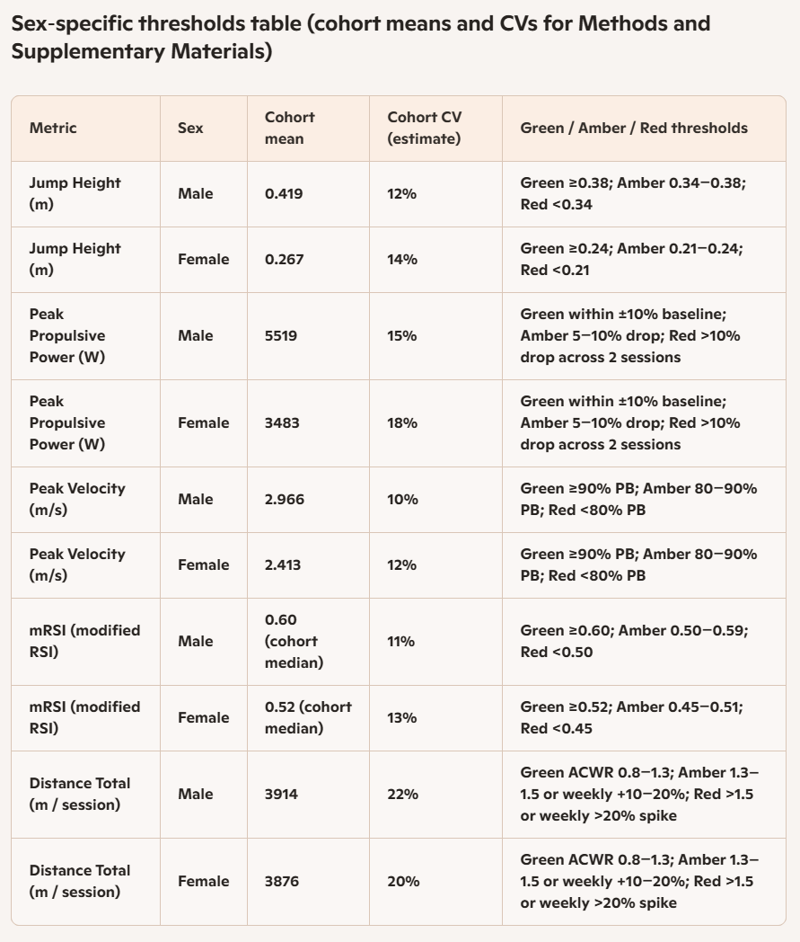

Notes for Methods and Supplementary Materials
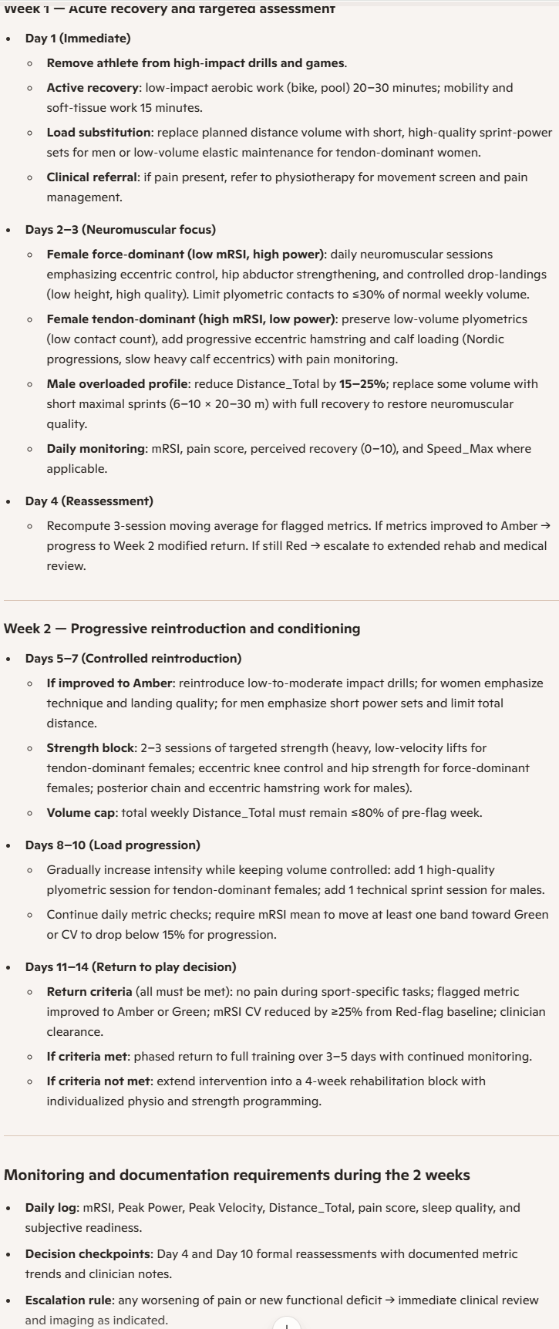

Templates for Methods and Supplementary Materials
Methods snippet for thresholds
“Sex-specific thresholds were applied using cohort means and coefficients of variation. Individual baselines were computed over a 6–12 week period. Green/Amber/Red bands were defined as shown in Supplementary Table X. Red flags required persistence across two consecutive sessions or the presence of pain and triggered a standardized 2-week intervention protocol.”
Supplementary Table caption
“Supplementary Table X. Sex-specific cohort means, estimated coefficients of variation, and operational thresholds used for readiness flagging. Thresholds were applied after individual baseline normalization.”
CITATIONS
- Neuromuscular readiness, RSI/mRSI, and jump metrics
Dos Santos T., Thomas C., Comfort P., Jones P. A. — The effect of a 6-week strength program on drop jump performance and reactive strength index. Journal of Strength and Conditioning Research. 2017;33(8):2140–2151.
Gathercole R., Sporer B., Stellingwerff T., Sleivert G. — Alternative countermovement-jump analysis to quantify acute neuromuscular fatigue. Int J Sports Physiol Perform. 2015;10(1):84–92.
- Tendon loading, tendinopathy, and elastic strategies
Rio E., Kidgell D., Purdam C., et al. — Tendon neuroplasticity: responses to loading and strategies to improve mechanotherapy. J Orthop Sports Phys Ther. 2015;45(11):842–852.
Kvist M. — Achilles tendon injuries in athletes. Sports Med. 1994;18(3):173–201.
- Workload, ACWR, and injury risk (volume spikes / "volume trap")
Gabbett TJ. — The training-injury prevention paradox: should athletes be training smarter and harder? Br J Sports Med. 2016;50(5):273–280.
Svilar L., Castellano J., Jukic I. — Load monitoring system in sport: Methods and applications. Strength & Conditioning Journal. 2019;40(2):26–33.
- Sex differences, ACL risk, and neuromuscular control
Hewett TE., Myer GD., Ford KR. — Biomechanical measures of neuromuscular control and valgus load on the knee predict anterior cruciate ligament injury risk in female athletes. Am J Sports Med. 2005;33(4):492–501.
Boden BP., Sheehan FT., Torg JS., Hewett TE. — Mechanisms of anterior cruciate ligament injury. Am J Sports Med. 2009;37(12):2439–2446.
- Hamstring strain and eccentric training (relevant to high-velocity profiles)
Askling CM., Tengvar M., Thorstensson A. — Hamstring injury occurrence in elite soccer players after preseason strength training with eccentric overload. Scand J Med Sci Sports. 2003;13(4):244–250.
APA
Dos Santos, T., Thomas, C., Comfort, P., & Jones, P. A. (2017). The effect of a 6-week strength program on drop jump performance and reactive strength index. Journal of Strength and Conditioning Research, 33(8), 2140–2151.
Gathercole, R., Sporer, B., Stellingwerff, T., & Sleivert, G. (2015). Alternative countermovement-jump analysis to quantify acute neuromuscular fatigue. International Journal of Sports Physiology and Performance, 10(1), 84–92.
Rio, E., Kidgell, D., Purdam, C., et al. (2015). Tendon neuroplasticity: responses to loading and strategies to improve mechanotherapy. Journal of Orthopaedic & Sports Physical Therapy, 45(11), 842–852.
Kvist, M. (1994). Achilles tendon injuries in athletes. Sports Medicine, 18(3), 173–201.
Gabbett, T. J. (2016). The training-injury prevention paradox: should athletes be training smarter and harder? British Journal of Sports Medicine, 50(5), 273–280.
Svilar, L., Castellano, J., & Jukic, I. (2019). Load monitoring system in sport: Methods and applications. Strength & Conditioning Journal, 40(2), 26–33.
Hewett, T. E., Myer, G. D., & Ford, K. R. (2005). Biomechanical measures of neuromuscular control and valgus load on the knee predict anterior cruciate ligament injury risk in female athletes. American Journal of Sports Medicine, 33(4), 492–501.
Boden, B. P., Sheehan, F. T., Torg, J. S., & Hewett, T. E. (2009). Mechanisms of anterior cruciate ligament injury. American Journal of Sports Medicine, 37(12), 2439–2446.
Askling, C. M., Tengvar, M., & Thorstensson, A. (2003). Hamstring injury occurrence in elite soccer players after preseason strength training with eccentric overload. Scandinavian Journal of Medicine & Science in Sports, 13(4), 244–250.

